# Web3 Practical: JQuery

For this practical, you are given HTML and CSS files for a simple restaurant menu, which lists the various dishes and their ingredients. The start of the menu is shown below:

­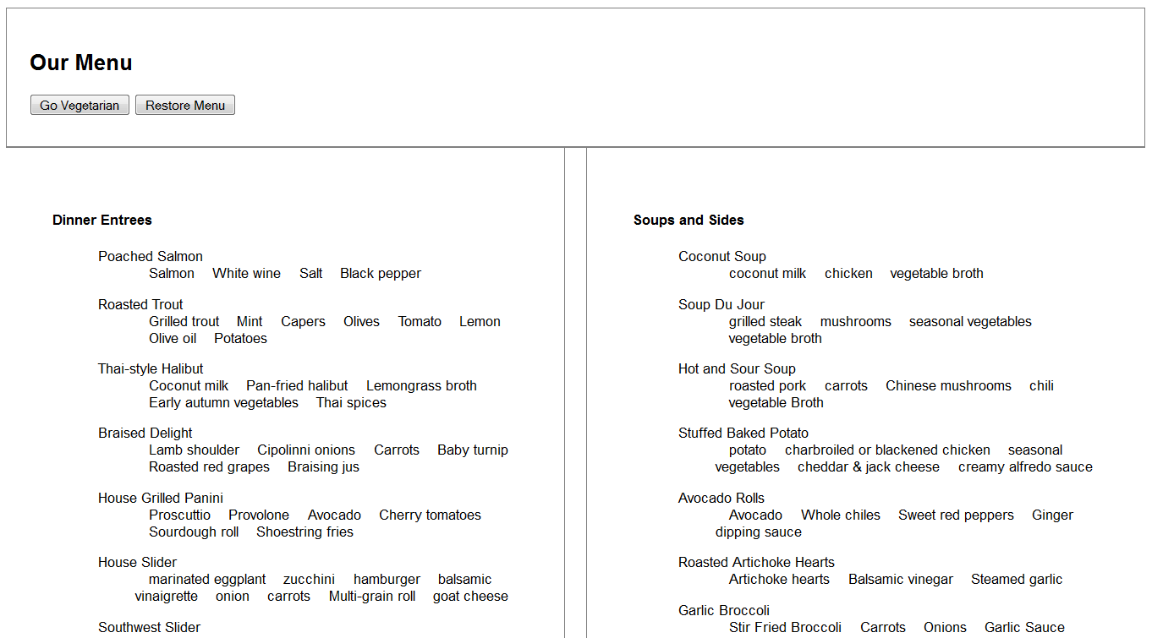

The HTML page includes two buttons, which are intended to toggle the page’s content between the standard menu (shown on page open, and above) and the restaurant’s alternative vegetarian menu. The differences between the two menus and the functionality you are required to implement using jQuery are:

1. Those entrees containing fish are removed completely from the vegetarian menu.
2. “Hamburger”, when it occurs as an ingredient in any dish, is replaced with “portobello mushrooms”.
3. Any other meat ingredient is replaced with “tofu”.
4. All those dishes that have been “vegetarianised” in the new menu are marked with a little leaf icon.

The vegetarian version should look like:

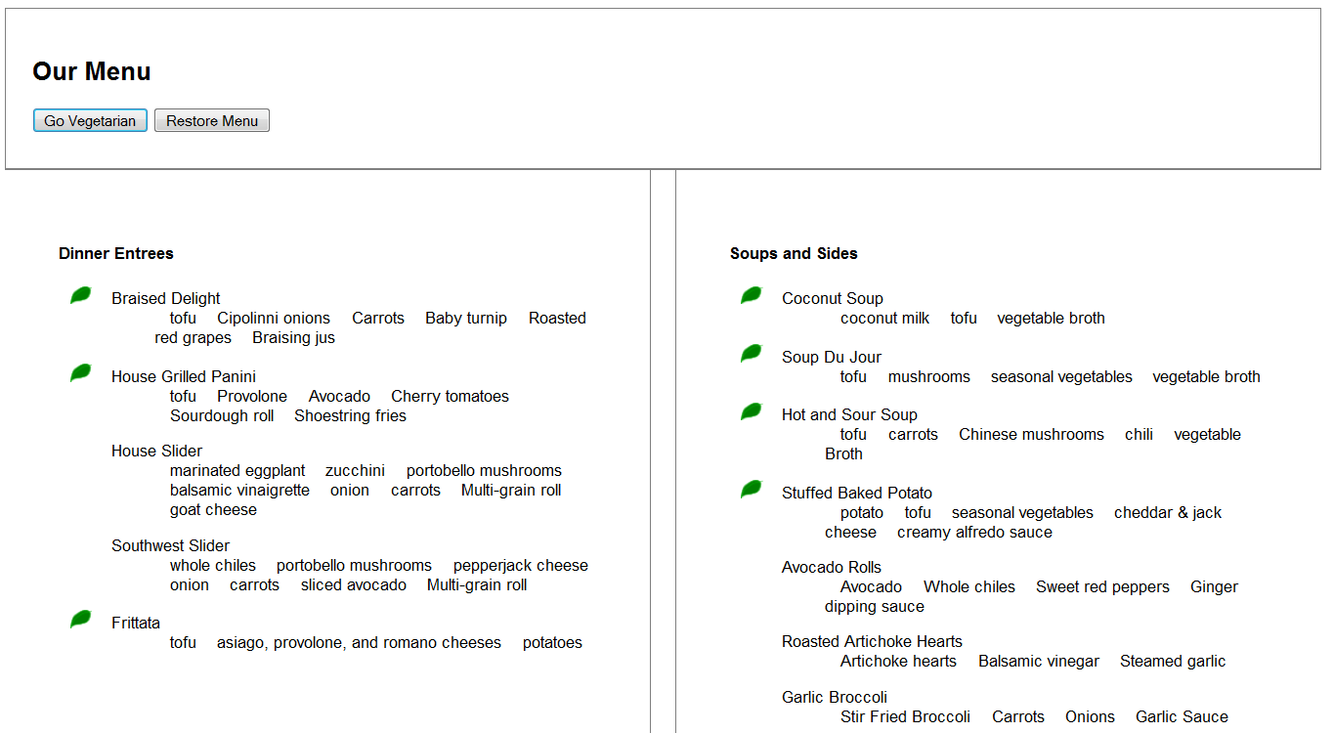

**Hint 1**: Useful jQuery functions that could be helpful in completing the practical.

.click

.detach

.replaceWith

.before()

.addClass

.first()

This list does not mean you absolutely need to use these functions to correctly complete the practical. There are many ways of doing the same thing in jQuery.

**Hint 2**: Think modular! Don’t write a bunch of code and test it when you are done only to find out it doesn’t work. Write small functions that carry out some of the functionality required one at a time and make sure they work before you proceed to write the next function.

**Hint 3**: maintain a global variable with the state of the menu (i.e. var stateVegetarian=true/false)

**Hint 4**: Some suggested functions you could write (with illustrative names) which could help you to organize your thoughts could be:

toggleVegetarian()

detachFish()

replaceHamburgers()

replaceMeat()

restoreFish()

restoreHamburgers()

restoreMeat()

**Good luck!**